Lec 04 Linked – List

**Circular linked list**

In the last node of a list, the link field often contains a [null](https://en.wikipedia.org/wiki/Null_pointer#Null_pointer) reference, a special value is used to indicate the lack of further nodes. A less common convention is to make it point to the first node of the list

* Access from one node to all other nodes.
* Head pointer is pointed to the last node
* Insert : O(1) , Delete : O(1) 🡨---------🡪 simple Linked list : insert at begin O(1), But O(n) in the end (traverse process)

[](https://en.wikipedia.org/wiki/File:Circularly-linked-list.svg)

**Double Linked list**

In a 'doubly linked list', each node contains, besides the next-node link, a second link field pointing to the 'previous' node in the sequence.

* One node has two links (before,after) ->search in both direction
* Takes more space , complex
* Easy to find preceding node
* Head node ; created to simplify insertion and deletion <-> head pointer
* In the blank, only the head node exists.

[](https://en.wikipedia.org/wiki/File:Doubly-linked-list.svg)

A doubly linked list whose nodes contain three fields: an integer value, the link forward to the next node, and the link backward to the previous node

A technique known as xor allows a doubly linked list to be implemented using a single link field in each node. However, this technique requires the ability to do bit operations on addresses, and therefore may not be available in some high-level languages.

**Linked List Application : Polynomial**

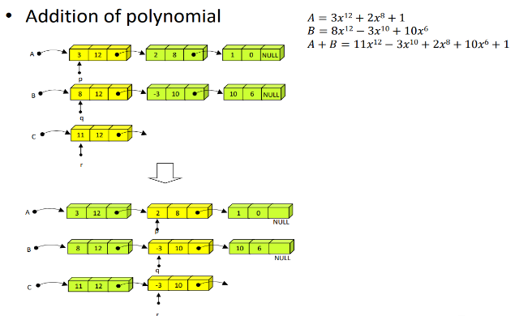

Use ListHeader (Length, *head, *tail)

-> do not have to use double pointer.

**List ADT using Linked List**

* Parameter of addition and deletion is position
* Parameter of `insert` and `remove` is the node pointer
* get_node_at: position -> node pointer

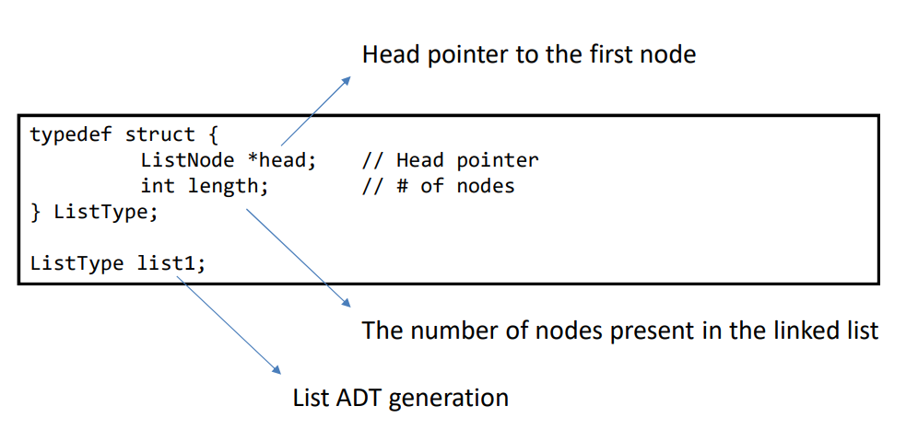

**Lec 05 Stack**

* Last in, First out
* time complexity of All operation is O(1).
* Top : top data in stack. (most recently typed)

**Function**

- peek(); only take the top data. Don’t delete.

- push(); full check. Add value in stack top

- pop(); empty check, take the top data and delete it

**Linked stack**

: stack using linked list

* The stack size is not limited
* Takes time to insert or delete